## 账单信息http://www.flipkard.com/

https://www.flipkart.com/

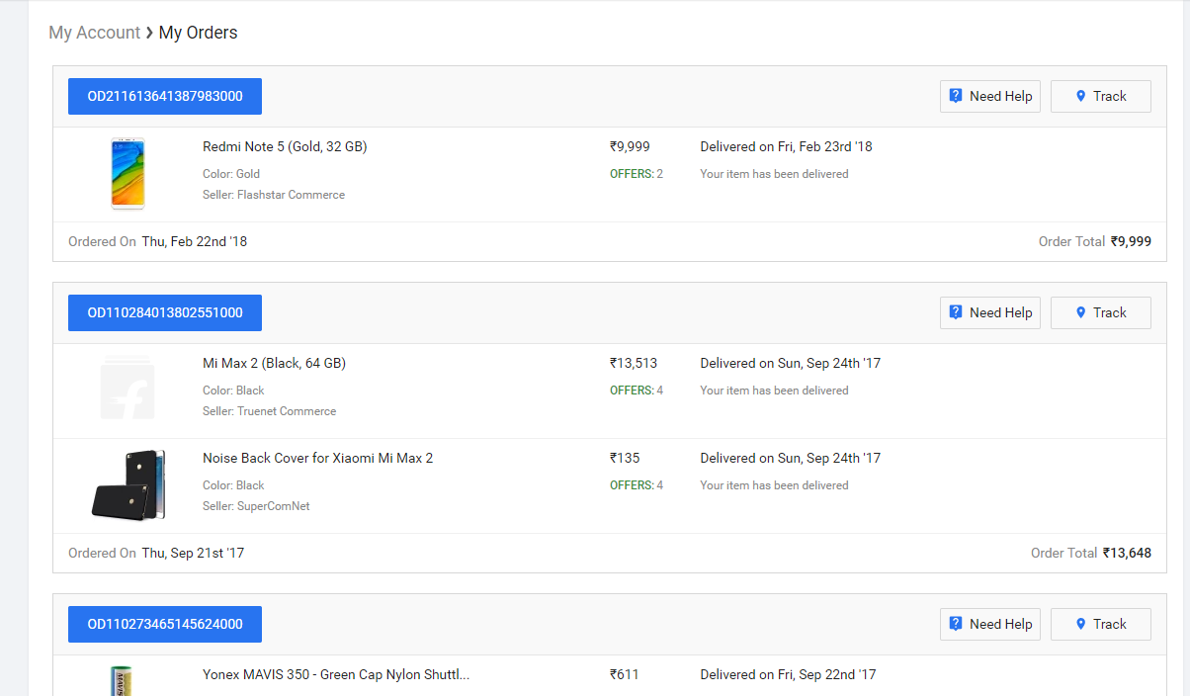

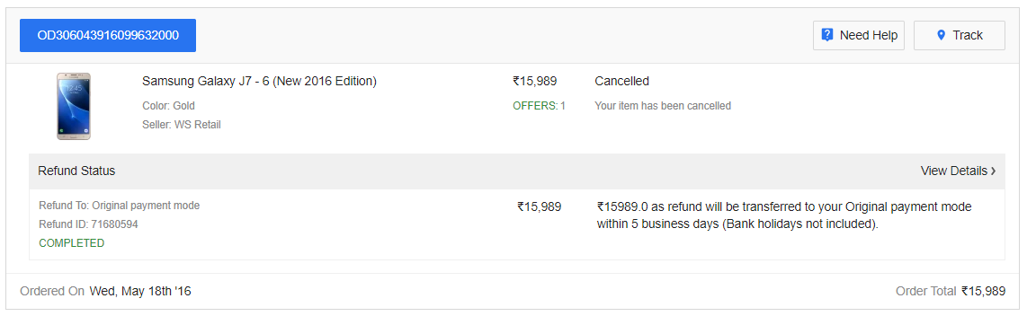

采集下面信息:

1. Order ID, Product Name (with details), Product Price, Product Delivery Date, Product Delivery Status, Product Offers (if any). (订单id,产品名称,产品价格,产品发货日期,产品物流状态,产品总供给数量)
2. Order ID, Order Delivery Date (left side below), Order Price (Order Total field) (订单id,订单发货状态,订单金额)
3. If Cancelled, then Refund Description, Refund Status (Completed in this case), Refund to, Refund ID(如果取消订单,采集退款描述、退款状态、退款订单编号、退款帐号）

Comment:

1. Apart from Product name (with details), also need to scrap Product category. Meanwhile, put Product Offers (if any) at low priority. （产品名称， 需要采集产品品类；不过，产品供给数量重要性较低，有就采集，没有就算）

2. Add the quantity of total orders and of total product items.（汇总总订单数量和以及每个订单的总产品数（个数））

3.Need to know the times of cancellation, put “Refund Description, Refund Status (Completed in this case), Refund to, Refund ID (if cancelled)” at low priority. 需要采集退款时间，退款相关的信息优先度低

Click on the Order ID or View Details link. （奠基订单id或者“view detail"链接； 进入订单详情）

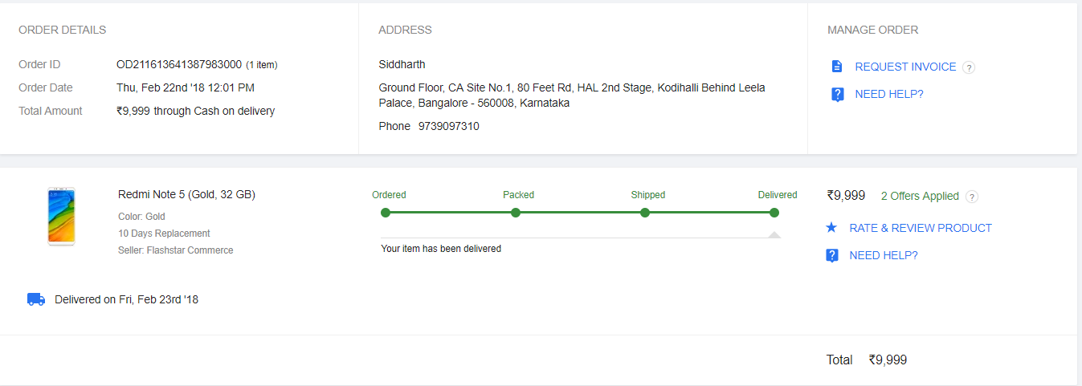

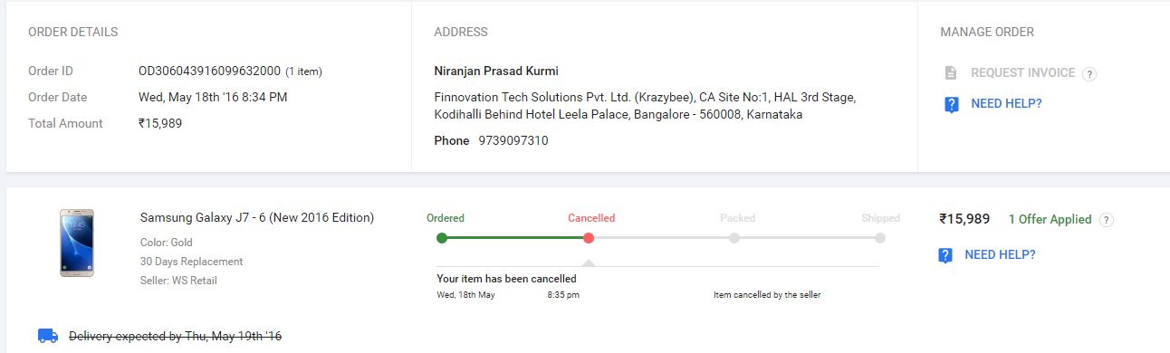

Scrap the following for each order:采集下列信息

1. Address地址
2. Phone Info联系电话

Comment: Add 3. Name for each order.收件人姓名

Note that the orders page refreshes after a page down (lazy loading feature). Need to get a list of all the orders for the account.注意，需要采集所有订单页的所有订单

## Personal Info个人信息页

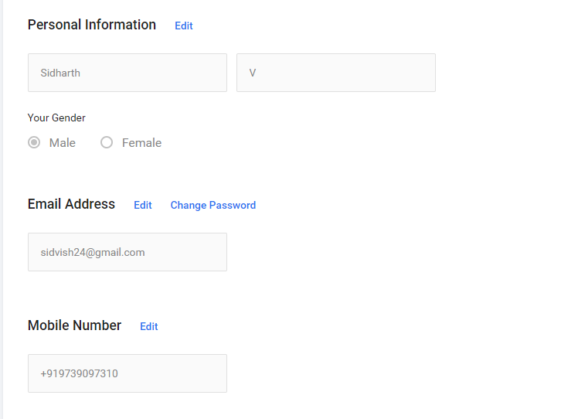

Scrap the following info:采集下列内容

1. First Name
2. Last Name
3. Gender
4. Email Address
5. Mobile Number

## Address Info 收件人地址信息

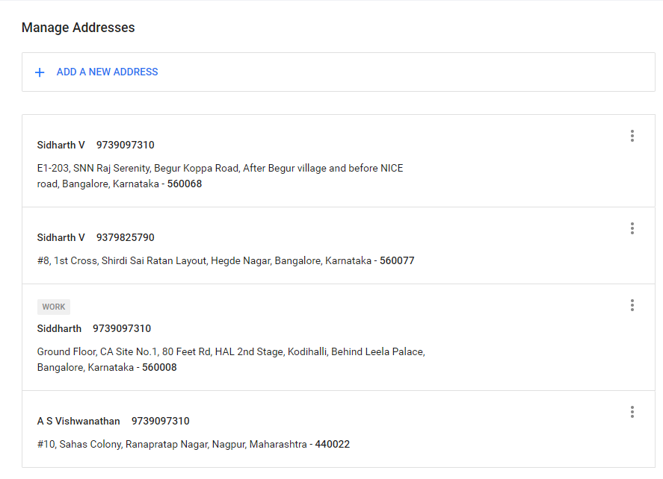

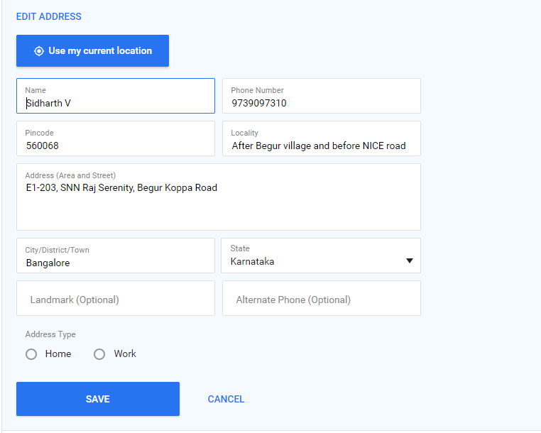

Scrap the following:五要采集下列信息

1. Name
2. Phone Number
3. Pincode
4. Locality
5. City/District/Town
6. State
7. Landmark(if available)
8. Alternate Phone (if available)
9. Address Type
10. Order (Is the most recently added item put to the top or the most recently used one? Need to check.)

## 通知类型

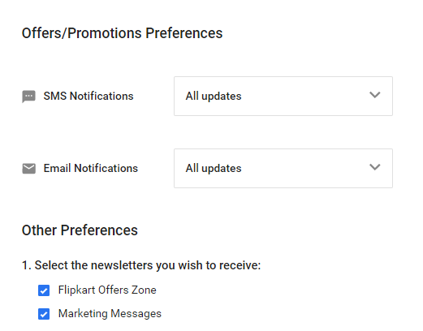

Scrap the following:采集下列信息

1. SMS Notification status
2. Email Notifications status

[Will check against the SMS sync to see if the messages have been deleted or not]

Comment: Put this requirement at low priority.低优先度

## PAN

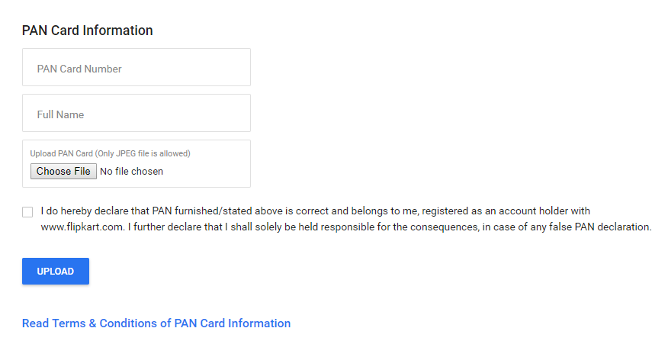

Scrap the following:采集下列信息

1. Pan Card Number
2. Full Name
3. Image of the PAN

## Phone Pe Wallet手机钱包余额

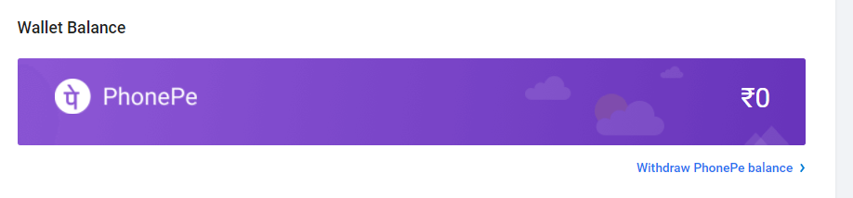Gift Card礼品卡

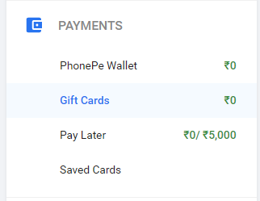

Scrap the following info:采集下列信息

1. Account Balance各帐户的帐户余额
2. <If the usage is not 0, need to check if there is something else that can be scrapped like the transactions>

Comment: If the usage is not 0, things to be scrapped (if there is any): 1) gift card transaction history (payment/receiving); 2) who has transacted into this account’s gift card; 3) anything else useful.

## Pay Later

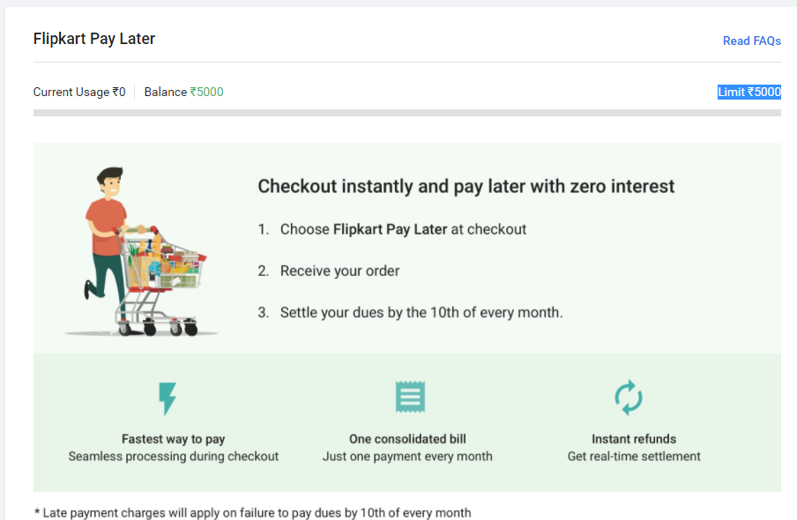

Scrap the following:

1. Current Usage
2. Balance
3. <If the usage is not 0, need to check if there is something else that can be scrapped like the transactions>

Comment: If the usage is not 0, things to be scraped (if there is any): 1) Pay later transaction history (repayment/credit change/etc); 2) delinquent history; 3) anything else useful.

## Saved Cards保存的银行卡信息

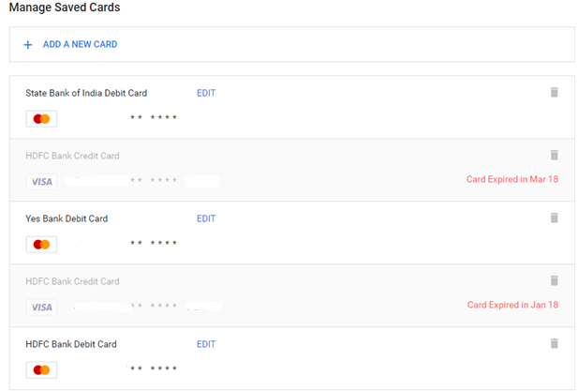

Scrap the following:采集下列内容

1. Card Name卡片名称
2. Card Number (Need to check if there are any legal implications of this? Do not scrap for now)’卡号先不采集
3. {}H:
4. Card Type (Visa/Master/Rupay based on the icon)卡片类型(VISIA,MASTER,RUPAY))
5. Instrument Type (Debit/Credit based on the name. If there is no debit or credit, then put as others)帐户类型（储蓄卡或者信用卡）
6. Card Status (Expired or not)
7. Order (Is the most recently added item put to the top or the most recently used one? Need to check.)

## Reviews

Click on My Reviews & Ratings

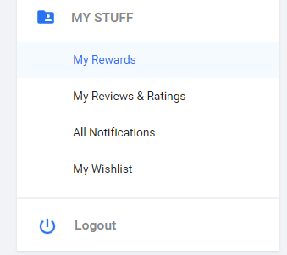

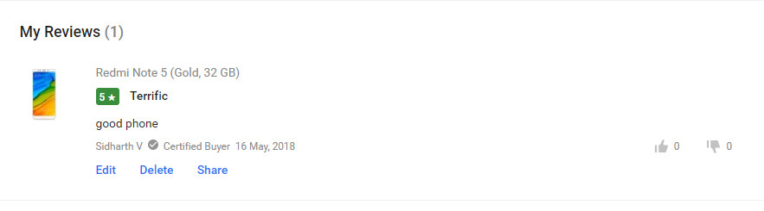

Scrap the following info:

* Total reviews
* Review product name
* Review rating
* Review description
* Review Date

帐号信息:

**vikram**

9597954836

abc@123

**vineeth**

9003367232 登入不了

abc@123

**Mridu 有订单**

8562851868

abc@123

**Adhitya**

[v.adhitya07@gmail.com](mailto:v.adhitya07@gmail.com" \t "_blank)

Abc@123